let's move on and take a look at date and time fields.

Date and time fields are not defined as numeric data types but are instead defined as character data types.

They're really just character strings that can be used in calculations. And this is made possible by the inbuilt automatic data type conversions that we've already discussed in a previous module and just like any other data type we use the data statement to declare these date and time fields. So, if we focus first on the date field. We will use a data type of D, which is always defined as eight characters, with the first four characters representing the year, the next two the month, and the next two the day. So, we would write it, we give it a name, my date type d. That's it, pretty simple.

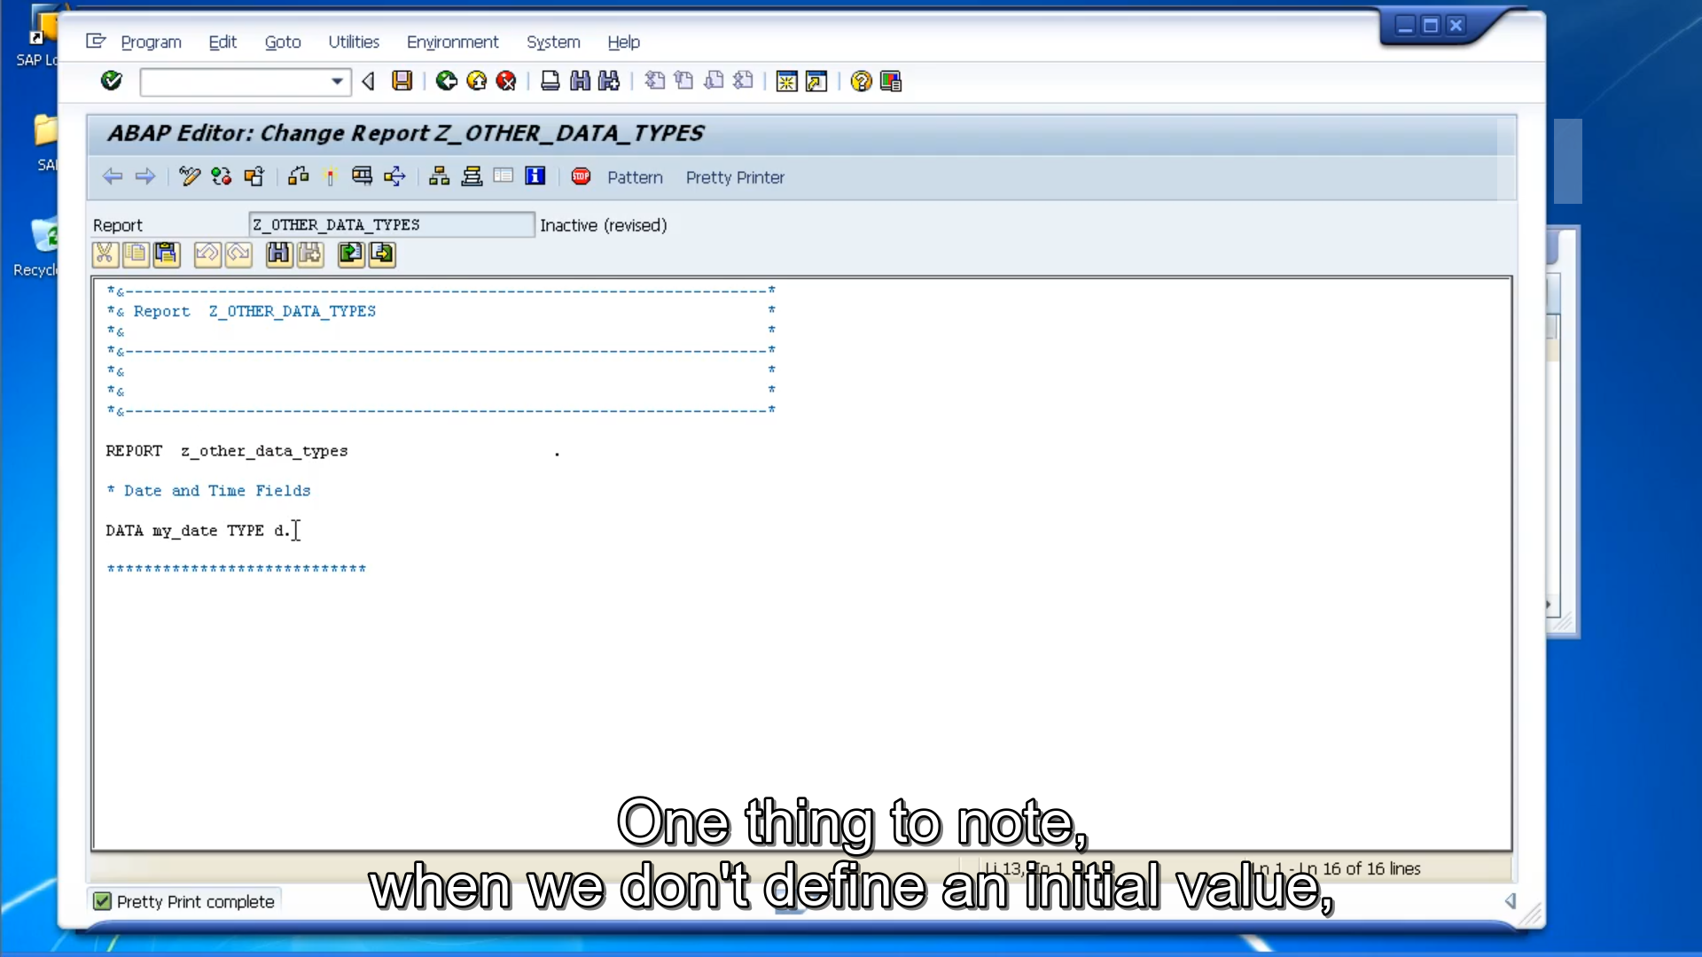

One thing to note, when we don't define an initial value, the system automatically assigns zeros to the field.

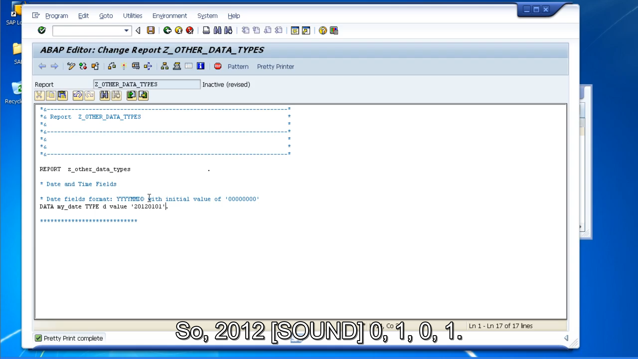

When you do want to an initial value just like any other field, we used the value addition. So, 20120101. And don't forget, like any other field, we are not just limited to using the time statement. If we already know a field defined as a day type and we want to reference that field.

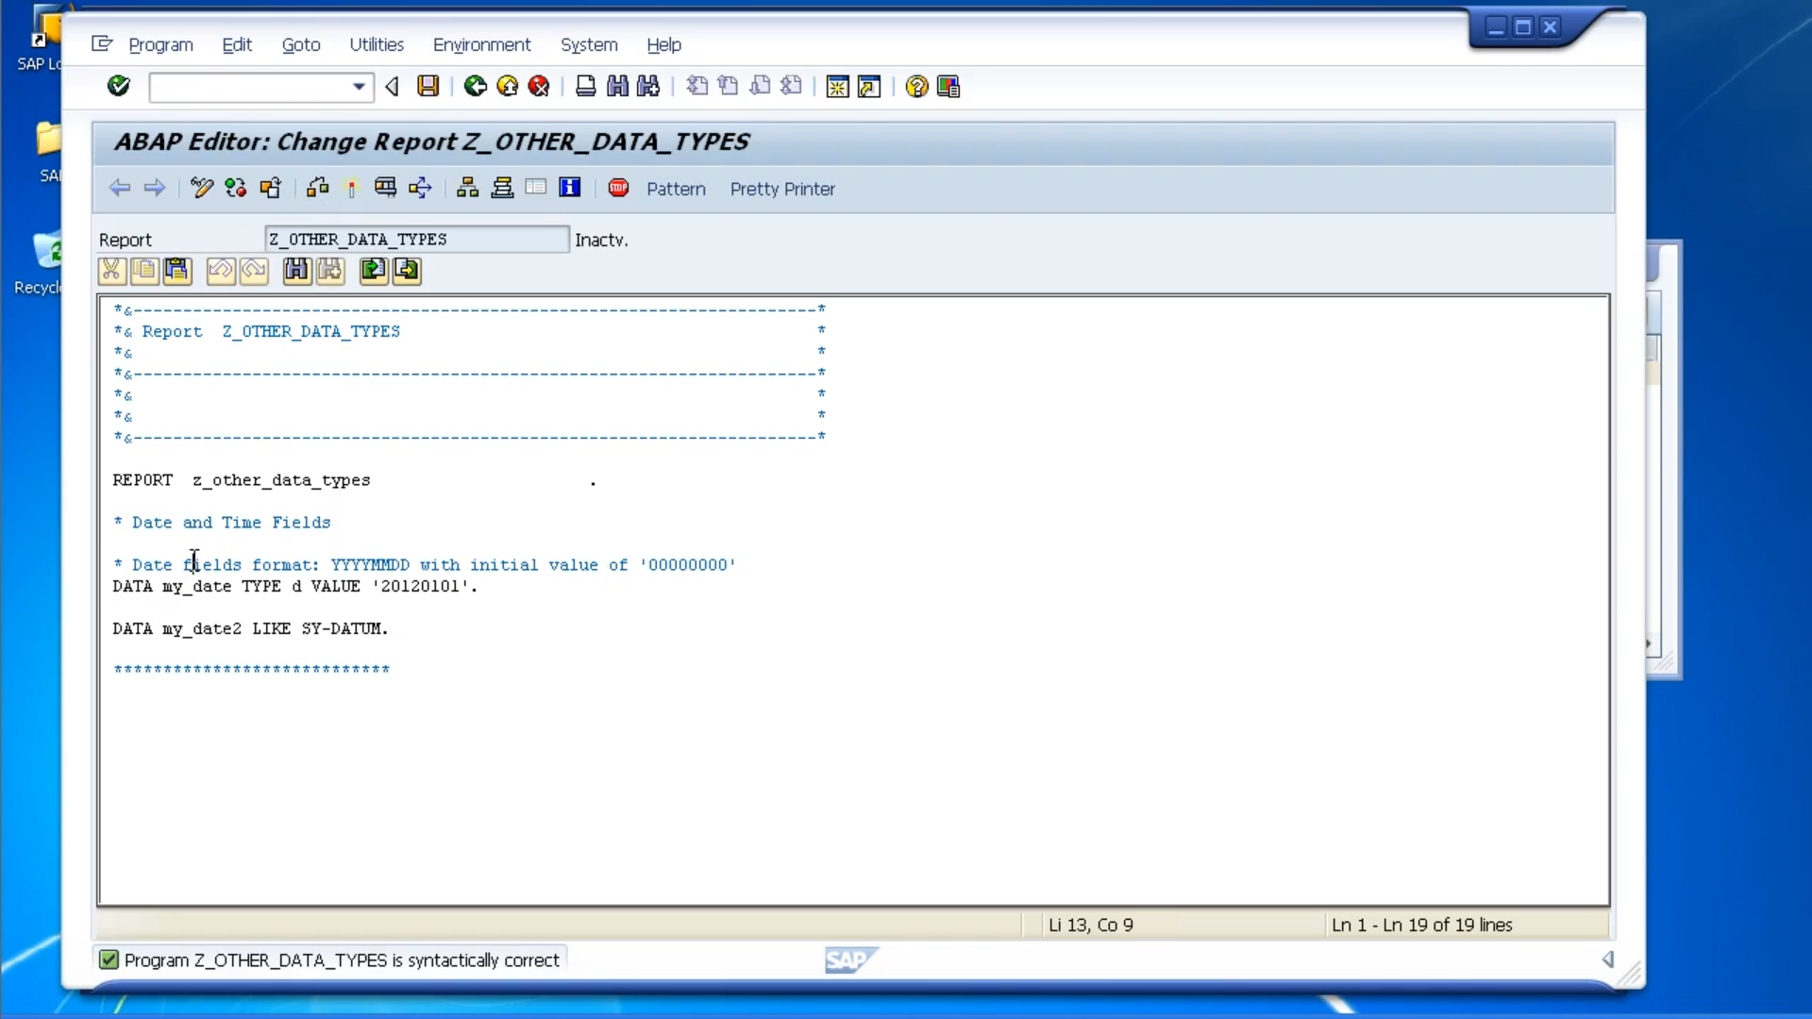

We can use the line statement. So, what's this one, SY datum? Well, this is a system variable that always holds the value of the system's date, so my date two field, we're defining it the same as DSY datum field.

Now let's move on to time fields. So, time fields are very similar to date Eight fields. But instead of being eight characters long, they are six characters. And they have the format of hour hour, minute minute, second second. And just as with the date field, the initial value is always zeroes.

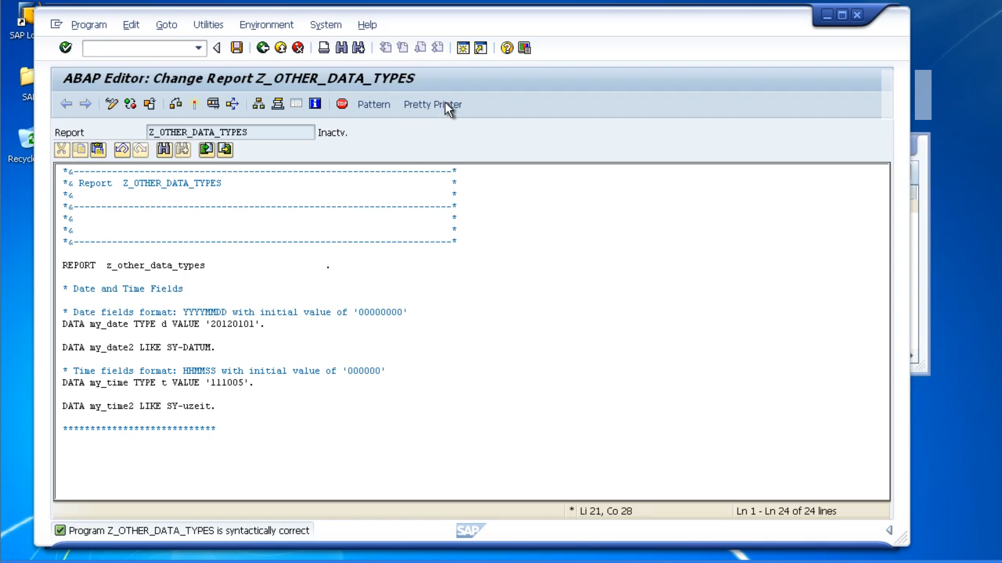

To define the time type, instead of D we use T. So, we can say 11 hours, ten minutes, five seconds is the value. When we want to reference an existing field, we will use the system time field, which is SY-UZEIT.

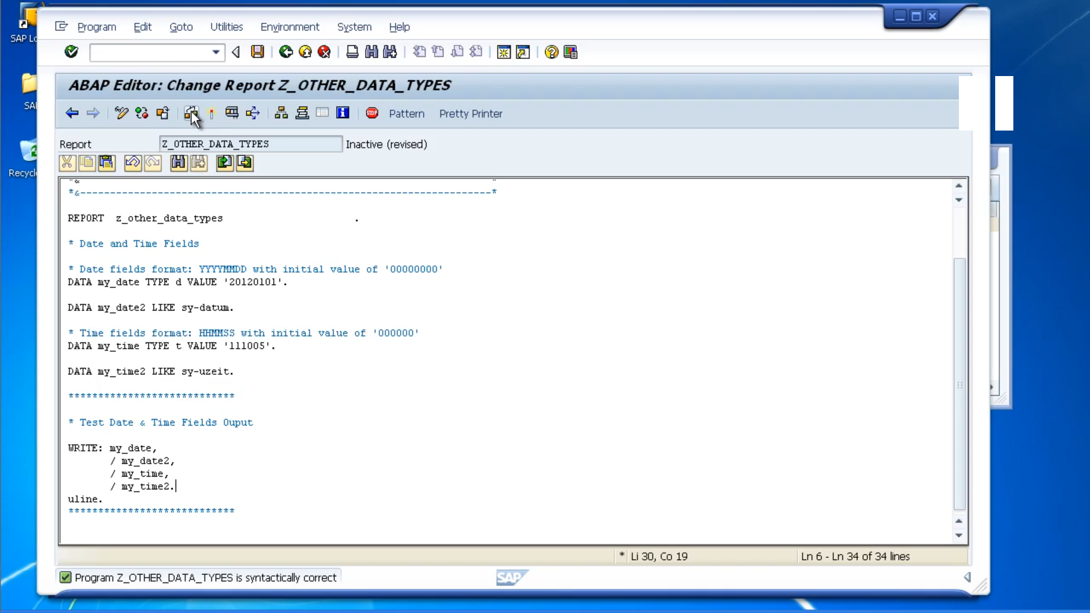

So, the output is showing us four fields,

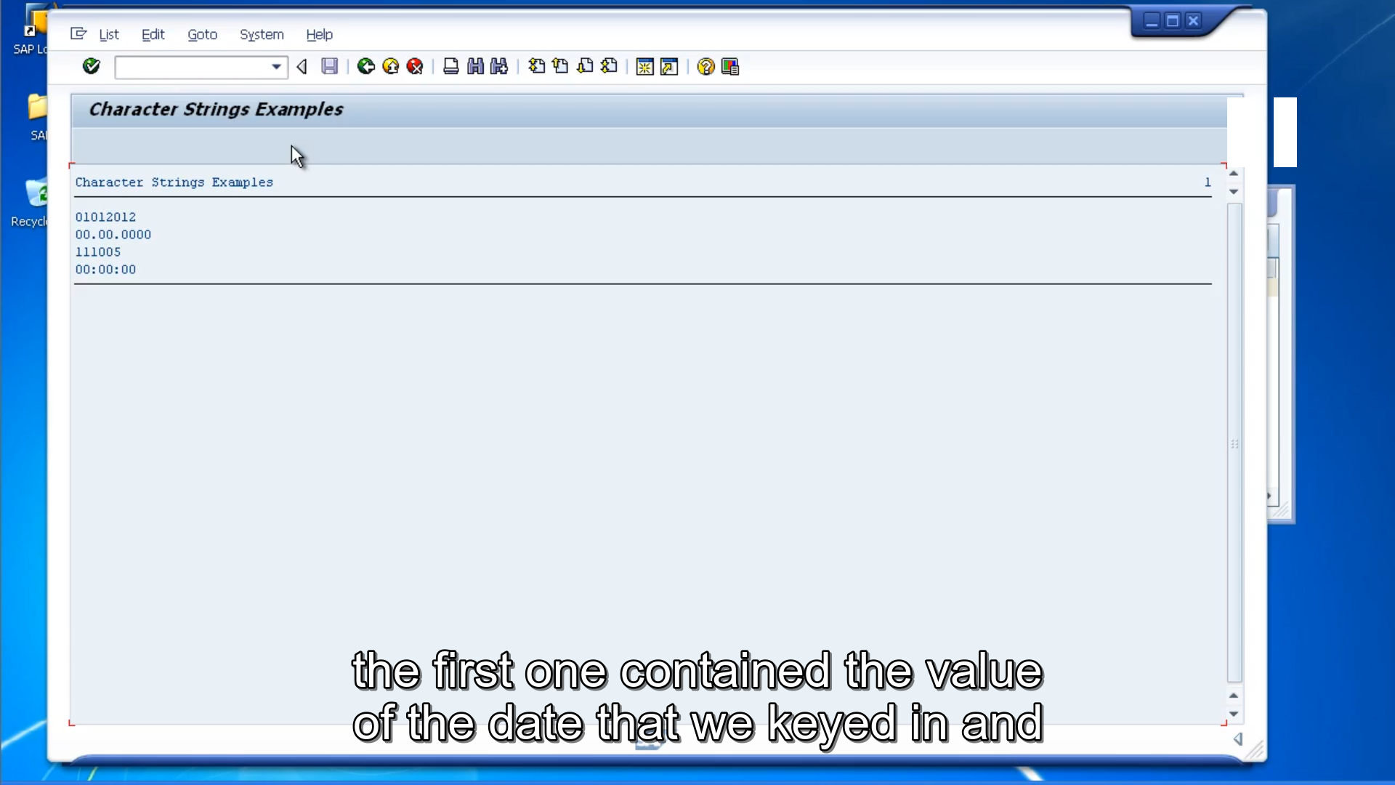

the first one contained the value of the date that we keyed in and the date declaration part, and we can see it's the 1st of January, 2012.

But remember how we keyed it in, in a reverse order. We did 2012, 01, 01, but the write statement applies its own formatting, and as we discussed in one of the previous modules, you can format the output as you like with the write statement.

A second field is a date field as well. But we didn't define any value to that date field so this system has output the initial value and it's used the automatic formatting by inserting periods between the day, month, and year, and it's using the formatting that associated with out user log on. The third and fourth, very similar again, we can see they are both time fields. The first one has a value and the second one doesn't.